 |  | Shut-off and regulating steel valves RTKZ R  ТУ 3742-001-71634056-2010
DN 15, 20, 25
PN 1,6; 2,5; 4,0; 6,3; 10,0; 16.0 MPа
RTKZ – shut-off and shut-off-regulating steel valves.
Designed for installation on pipelines as a shut-off and regulating device.
RTKZ10 P – series of shut-off valves with forged-welded bodies, gland mounting on studs.

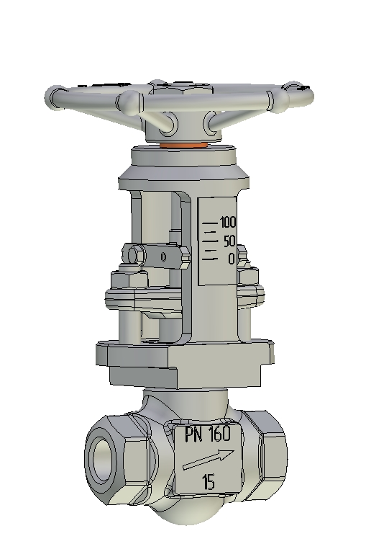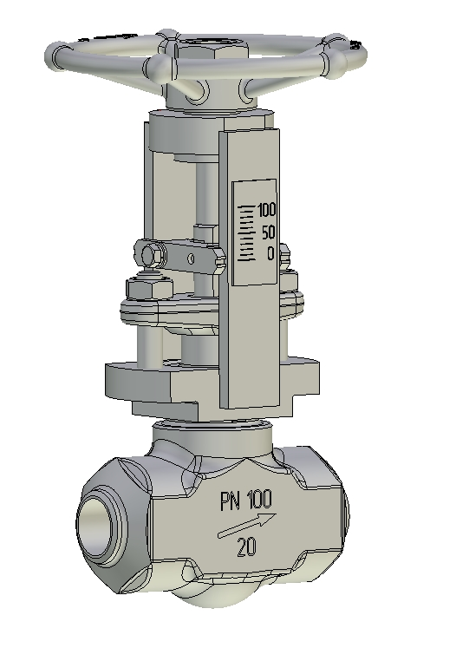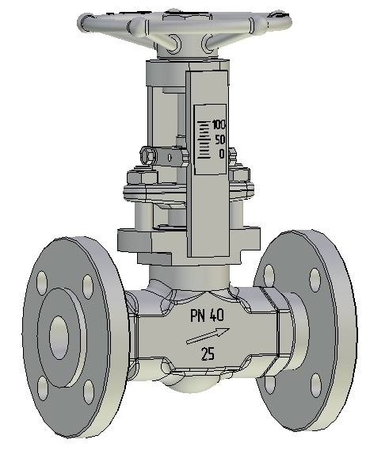
Stop and control valves
Advantages:
Sealing surfaces of the gate are made of wear-resistant and corrosion-resistant materials of hardness.
Shutoff-regulating valves differ from shutoff valves in that they contain a regulating element made in the form of a hollow cylinder with radial holes (cages). The arrangement of holes allows smoothly increase or decrease the valve cross-section, thus providing a change in the flow rate of the medium.
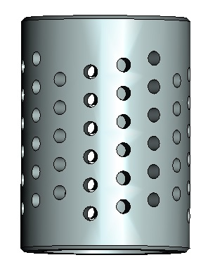
The water throughput values of the valves DN 20 and DN 25 are shown in the graphs below.
The profile of the regulating body provides more accurate dosing of the flow rate of the conducted medium at the beginning of valve opening (from 5 to 30% of the spool stroke). With further opening of the valve, the change in the flow rate of the conducted medium increases more significantly.
Valves can be manufactured with other flow characteristics.
The body is made of pressed billet, has a high safety margin, the packing chamber is located directly in the body, there is no cover, which simplifies the design and increases the reliability of the valve.
The valve can be operated at full differential pressures, adjusted at the differential pressures specified in the accompanying documentation for the valve, with low control forces. This ensures a high tightness of the valve according to class "A".
It is possible to produce valves with non-standard and extended construction lengths.

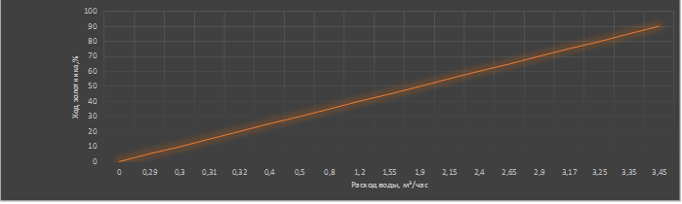

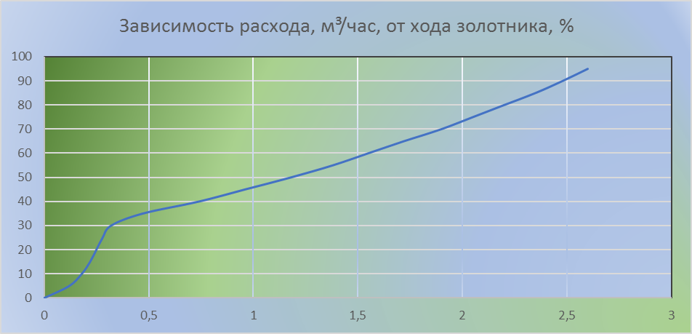

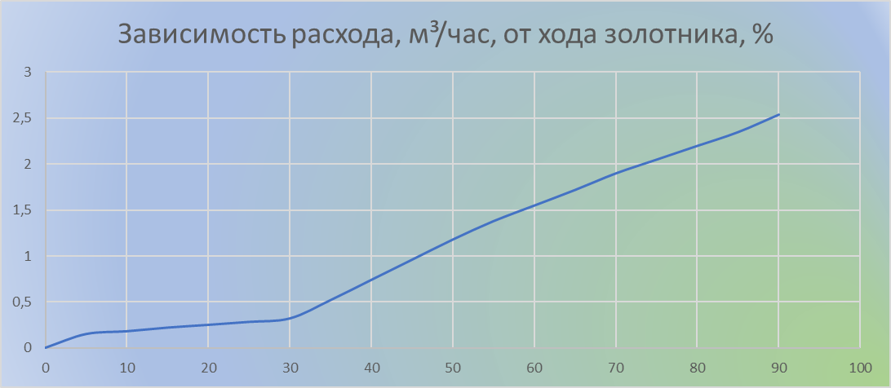

Water throughput graphs for valves DN 20 and DN 25

Technical characteristics of PTKZ P valves:

Показатель | Значение | Примечание
Purpose | For installation on pipelines as shut-off and control devices
Manufacturing standard | ТУ 3742-001-71634056-2010
Type of fitting | shut-off and regulating
Type of armature | Shut-off and regulating valves RTKZ | RTKZ10 Р
Seal tightness class | class "A", "B", "C", "D" GOST 9544
Conducted medium | Water, steam, oil, liquid and gaseous petroleum products, water-gas-oil mixtures, natural and associated gas, other media against which the material of valve parts is corrosion-resistant | To be specified when ordering.  For corrosive media, the concentration of active substances is indicated.
Conducted medium temperature | minus 60ºC to 200ºC, depending on the material of the valve components | To be specified when ordering  In the absence of requirements is supplied according to the technical documentation of LLC "RTMT"
Climatic version | Y1, CHL1, UHL1, T1 GOST 15150.  Other types of climatic versions and placement categories are allowed. | To be specified when ordering
Seismic resistance category | - non-seismic CO version (up to 6 points inclusive on MSK-64 scale);  - earthquake-resistant version C (over 6 to 9 points inclusive);  - PS version of increased seismic resistance (over 9 to 10 points inclusive). | To be specified when ordering.  If there is no requirement, it is supplied in non-seismic (C0) version
Setting position | any
Spindle seal | Gland packing, with packing rings made of thermally expanded graphite
Type of control | manual
Pipeline connection | - coupling (G, Rc, K);  - flanged GOST 33259  versions A, B, C, D, D, E, F, J, K, L, M;  - flanged GOST 9033, ANSI/ASME B16.5;  - flanged with mating flanges;  - butt welded;  - socket welded. | To be specified when ordering.  For coupling valves, the size of the connection thread is indicated, for flanged valves, the flange design and the standard for the mating flanges. For welded versions and mating flanges it is possible to make a pipe-specific cut-out.  If there are no requirements for flange execution or cutting for a specific pipe, it is supplied according to technical documentation.  LLC "RTMT".
Type of coverage | Factory anti-corrosion coating,  specialty coating | To be specified when ordering. If not required, supplied with factory corrosion protection coating
Average service life | 20 years
Maximum flow capacity, Kv, m³/hour | DN 15 – to 1,6  DN 20 and DN 25 – to 2,5

Shut-off and regulating valves RTKZ R
(series RTKZ10 R)
ТУ 3742-001-71634056-2010
DN 15, 20, 25
PN 1,6; 2,5; 4,0; 6,3; 10,0; 16,0 MPa

Table-figure: 15c68nj; 15ls68nj; 15nj68nj.
Fig. 1

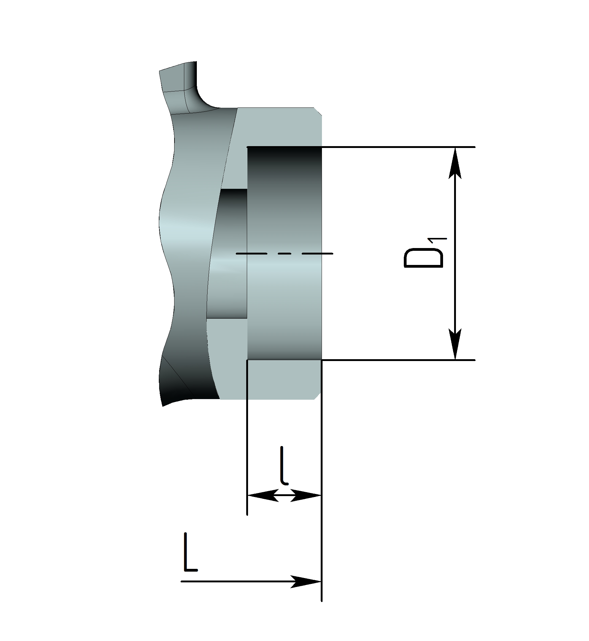
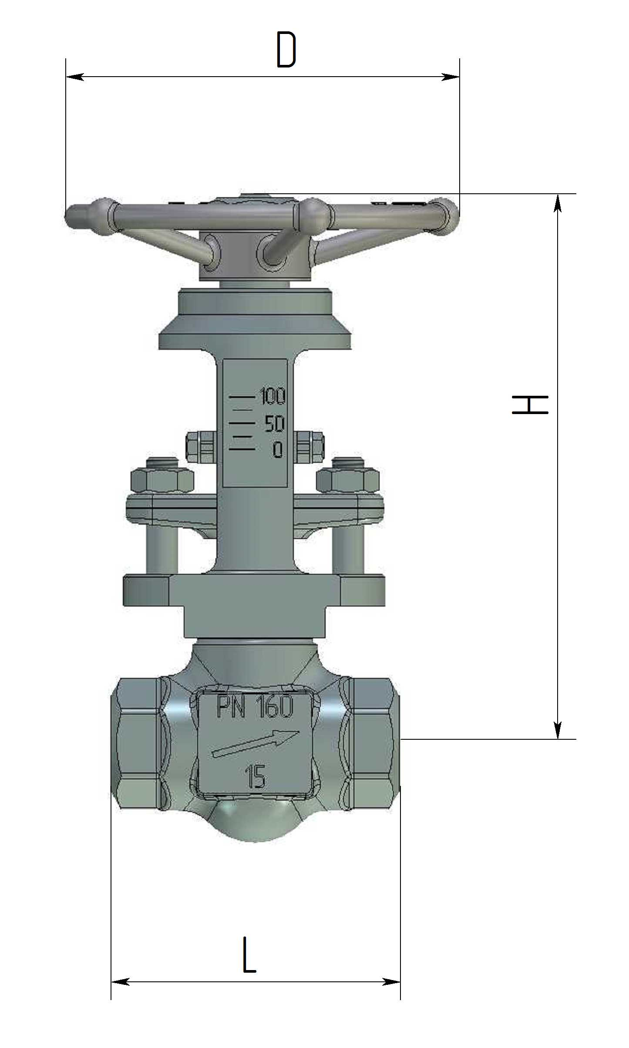
Fig. 5
For the rest see. fig.1
Fig. 4
For the rest see Fig.1
Fig. 3
For the rest see Fig.1
Fig. 2
For the rest see Fig.1

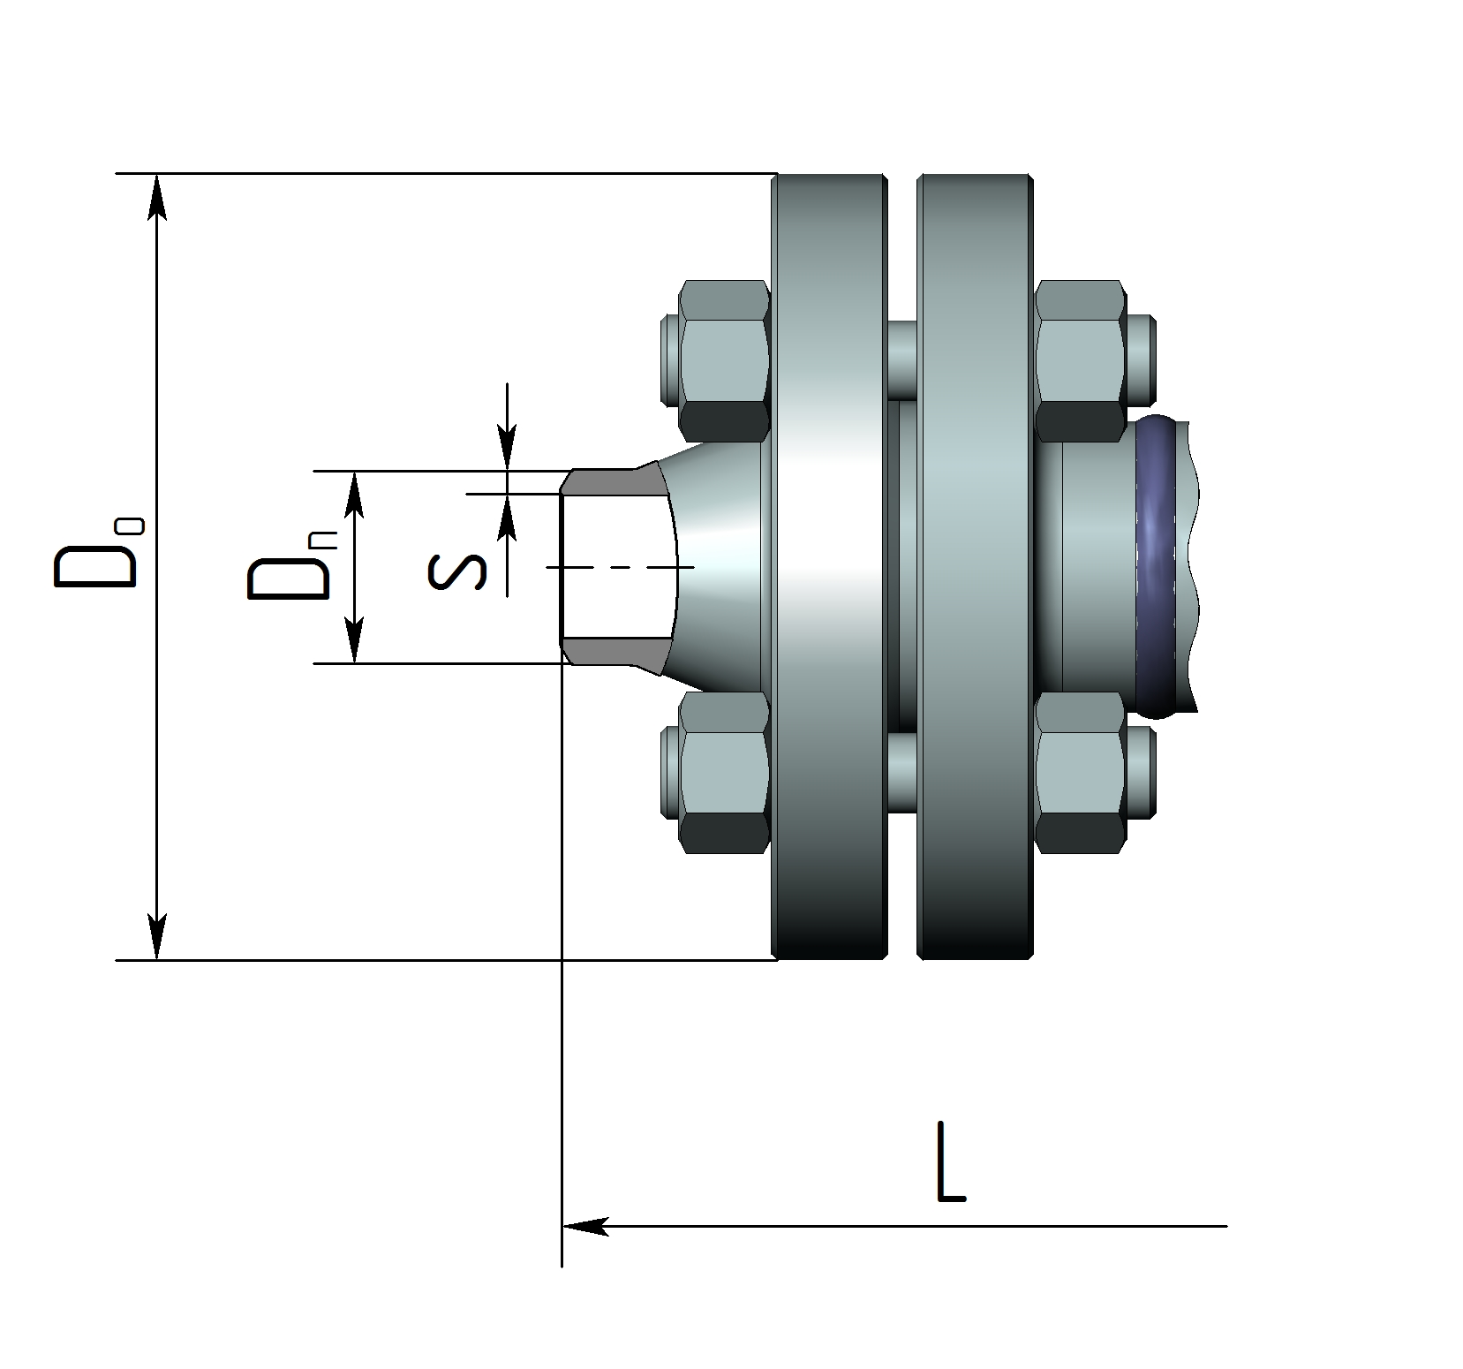
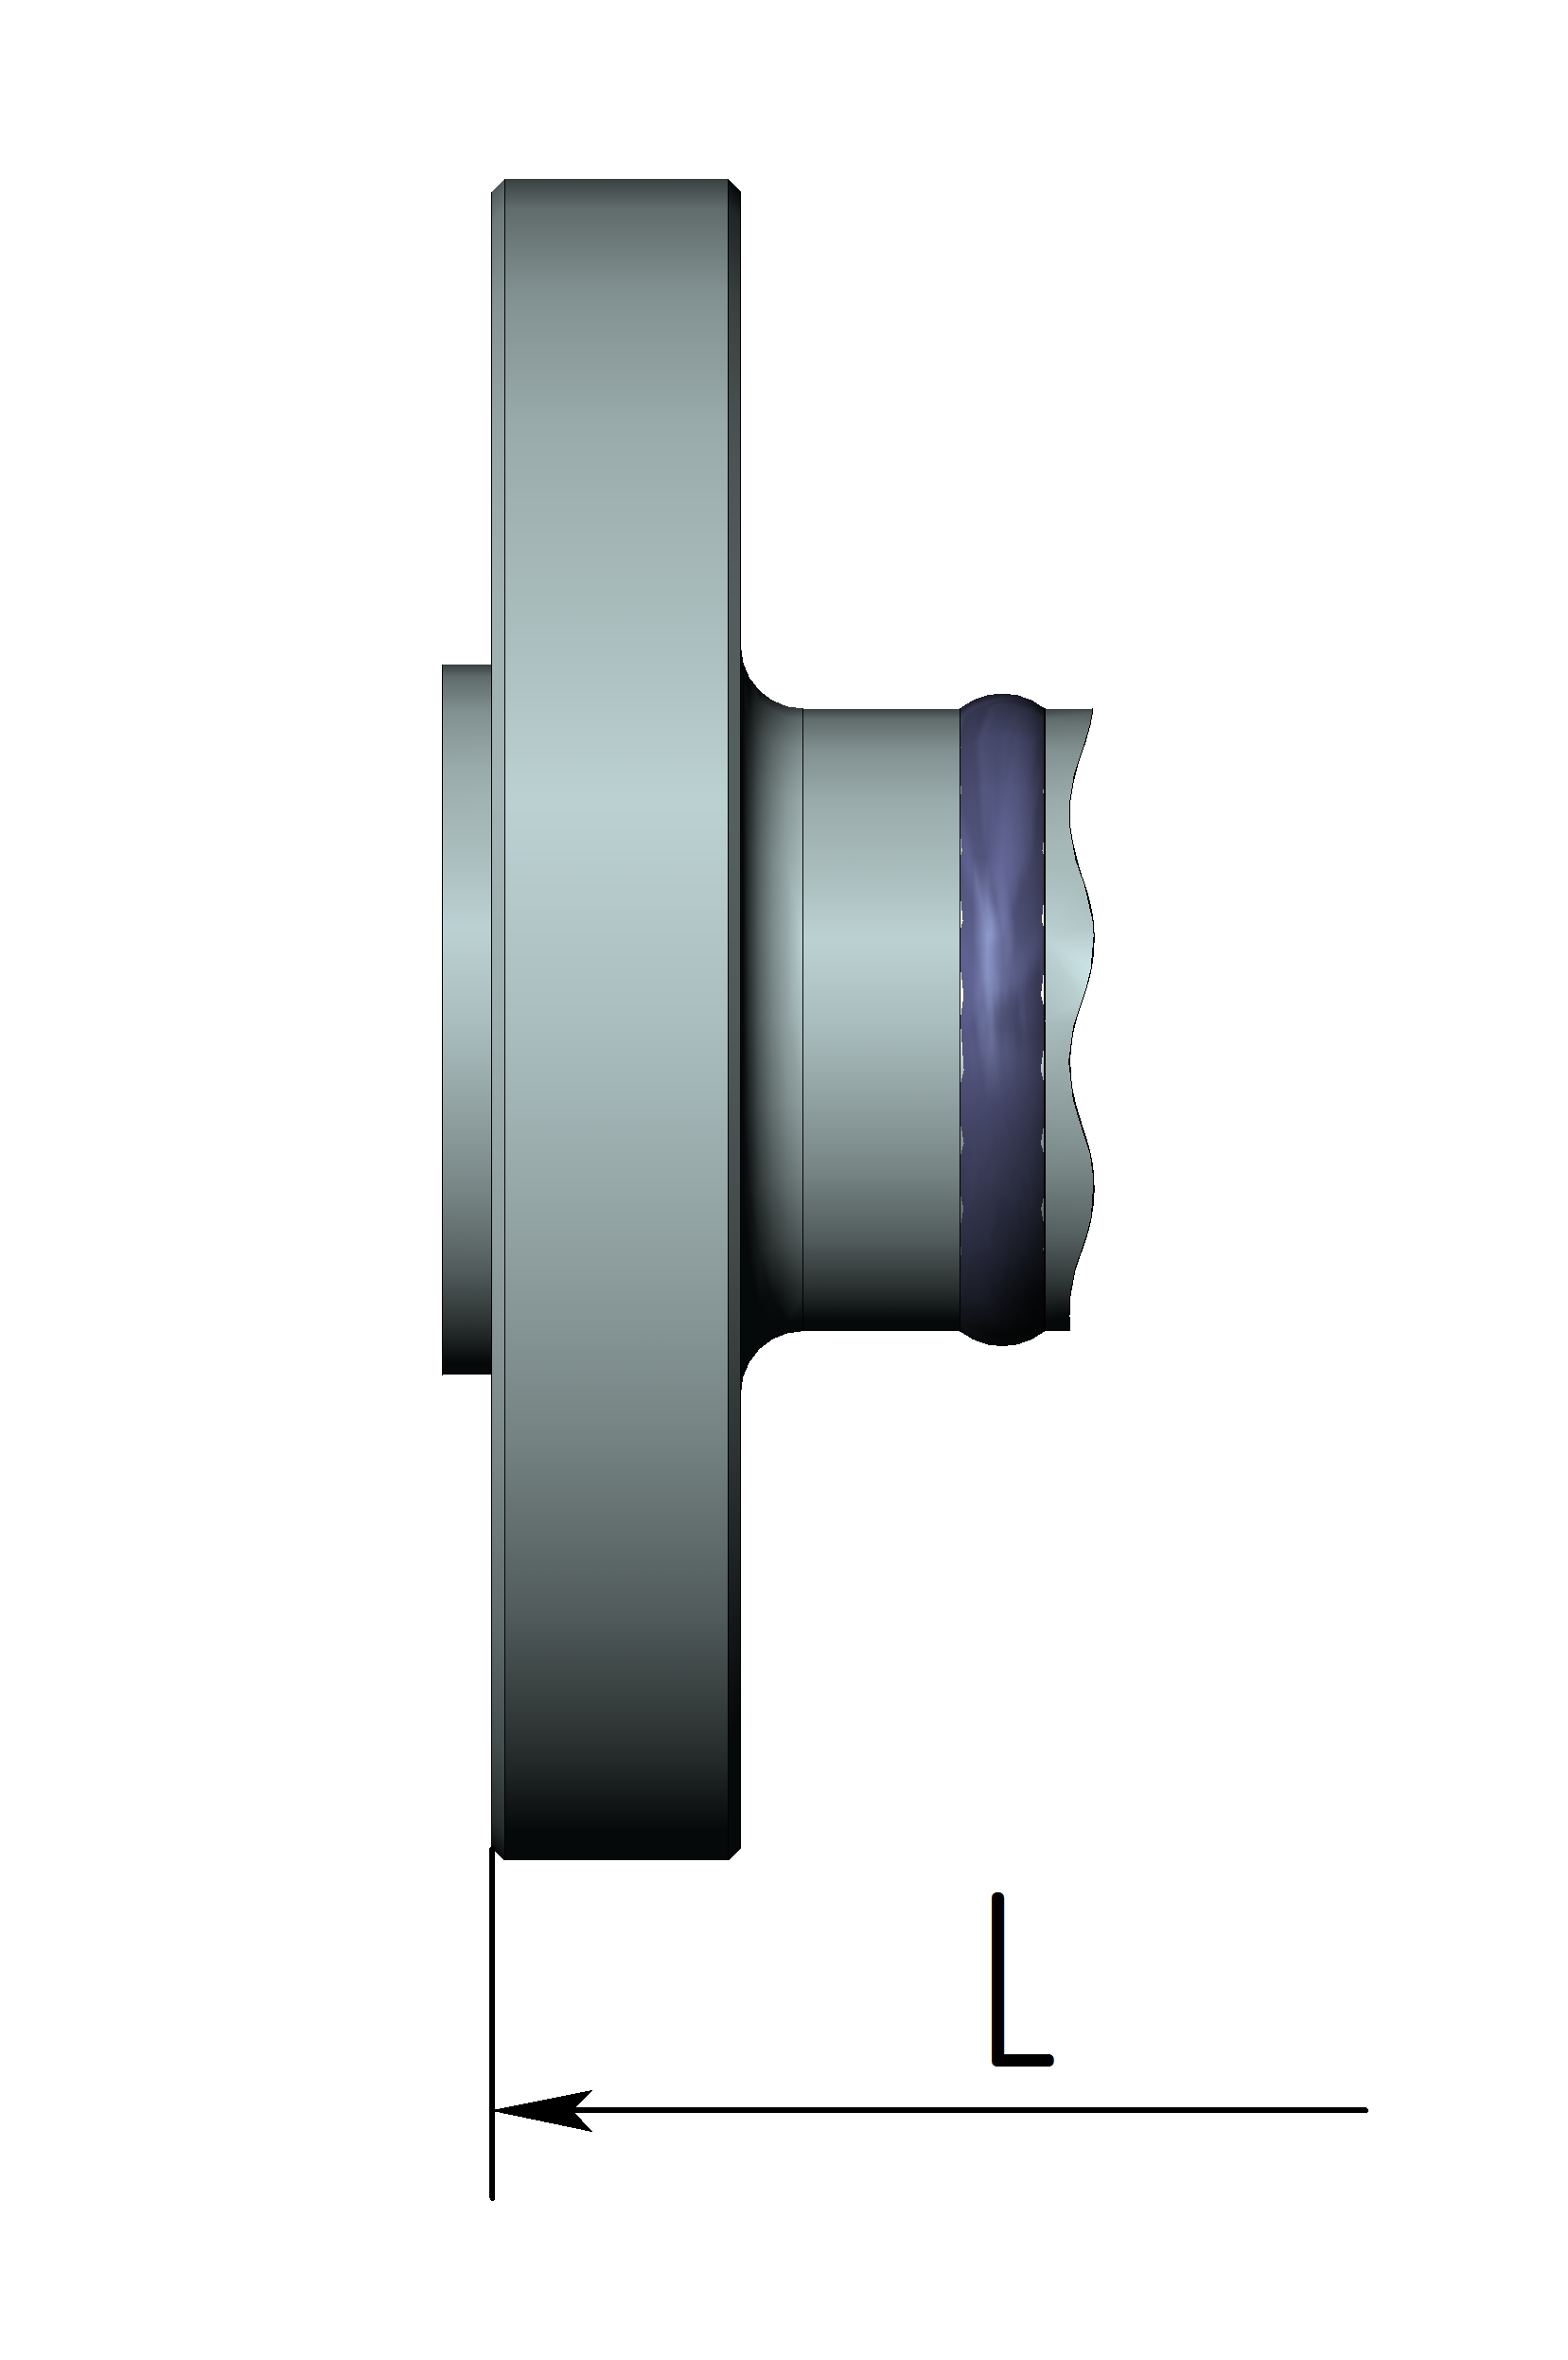

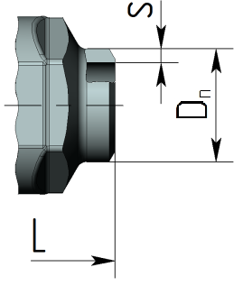

Table of basic dimensions for flange connections:

DN | Connection  method | PN,  МPа | Dimentions, mm |  |  |  |  |  |  | Mass,  kg | Fig.
DN | Connection  method | PN,  МPа | L | Н | D | D0 | b | Dn* | S* | Mass,  kg | Fig.
 | Flanged | 1,6 | 122 |  |  | 95 | 12 | – | – | 4,3 | 1,2
 | With mating flanges | 1,6 | 192 |  |  | 95 | 12 | 19 | 3,5 | 6,3 | 1,3
 | Flanged | 2,5 | 118 |  |  | 95 | 14 | – | – | 4,3 | 1,2
 | With mating flanges | 2,5 | 194 |  |  | 95 | 14 | 19 | 3,5 | 6,7 | 1,3
 | Flanged | 4,0 | 118 |  |  | 95 | 14 | – | – | 4,3 | 1,2
 | With mating flanges | 4,0 | 194 |  |  | 95 | 14 | 19 | 3,5 | 6,7 | 1,3
 | Flanged | 6,3 | 130 |  |  | 105 | 16 | – | – | 5,0 | 1,2
15 | With mating flanges | 6,3 | 236 | 140 | 120 | 105 | 16 | 19 | 3,5 | 8,1 | 1,3
 | Flanged | 10,0 | 130 |  |  | 105 | 18 | – | – | 5,2 | 1,2
 | With mating flanges | 10,0 | 236 |  |  | 105 | 18 | 19 | 3,5 | 8,5 | 1,3
 | Flanged | 16,0 | 130 |  |  | 105 | 18 | – | – | 5,2 | 1,2
 | With mating flanges | 16,0 | 236 |  |  | 105 | 18 | 19 | 3,5 | 8,5 | 1,3
 | With mating flanges | 16,0 | 294 |  |  | 120 | 23 | 21 | 4,5 | 11,0 | 1,3
 | Flanged | 1,6 | 142 |  |  | 105 | 12 | – | – | 5,0 | 1,2
 | With mating flanges | 1,6 | 218 |  |  | 105 | 12 | 26 | 4,0 | 7,6 | 1,3
 | Flanged | 2,5 | 138 |  |  | 105 | 14 | – | – | 5,3 | 1,2
 | With mating flanges | 2,5 | 216 |  |  | 105 | 14 | 26 | 4,0 | 8,1 | 1,3
 | Flanged | 4,0 | 138 |  |  | 105 | 14 | – | – | 5,3 | 1,2
 | With mating flanges | 4,0 | 216 |  |  | 105 | 14 | 26 | 4,0 | 8,1 | 1,3
 | Flanged | 6,3 | 154 |  |  | 125 | 18 | – | – | 6,7 | 1,2
20 | With mating flanges | 6,3 | 264 | 185 | 120 | 125 | 18 | 26 | 4,0 | 11,7 | 1,3
 | Flanged | 10,0 | 154 |  |  | 125 | 20 | – | – | 6,9 | 1,2
 | With mating flanges | 10,0 | 276 |  |  | 125 | 20 | 26 | 4,0 | 12,3 | 1,3
 | Flanged | 16,0 | 154 |  |  | 125 | 22 | – | – | 6,9 | 1,2
 | With mating flanges | 16,0 | 276 |  |  | 125 | 22 | 26 | 4,0 | 12,3 | 1,3
 | With mating flanges | 16,0 | 340 |  |  | 130 | 26 | 27 | 4,0 | 14,0 | 1,3
 | Flanged | 1,6 | 162 |  |  | 115 | 12 | – | – | 5,6 | 1,2
 | With mating flanges | 1,6 | 242 |  |  | 115 | 12 | 33 | 4,0 | 8,5 | 1,3
 | Flanged | 2,5 | 158 |  |  | 115 | 14 | – | – | 5,9 | 1,2
 | With mating flanges | 2,5 | 240 |  |  | 115 | 14 | 33 | 4,0 | 9,1 | 1,3
 | Flanged | 4,0 | 158 |  |  | 115 | 14 | – | – | 5,9 | 1,2
 | With mating flanges | 4,0 | 240 |  |  | 115 | 14 | 33 | 4,0 | 9,1 | 1,3
 | Flanged | 6,3 | 178 |  |  | 135 | 20 | – | – | 7,8 | 1,2
25 | With mating flanges | 6,3 | 304 | 185 | 120 | 135 | 20 | 33 | 4,0 | 13,2 | 1,3
 | Flanged | 10,0 | 178 |  |  | 135 | 22 | – | – | 8,1 | 1,2
 | With mating flanges | 10,0 | 304 |  |  | 135 | 22 | 33 | 4,0 | 14,9 | 1,3
 | Flanged | 16,0 | 178 |  |  | 135 | 22 | – | – | 8,1 | 1,2
 | With mating flanges | 16,0 | 304 |  |  | 135 | 22 | 33 | 4,0 | 14,9 | 1,3
 | With mating flanges | 16,0 | 372 |  |  | 149 | 29 | 33 | 5,5 | 17,6 | 1,3

Valve delivery with mating flange connection includes: flanged valve complete with mating flanges, fasteners and gaskets.

Table of basic dimensions for coupling, welded and butt welded couplings
butt weld:

DN | Pipeline connection | PN,  МПа | Dimensions, mm |  |  |  |  |  |  | Threading | Weight,kg | Fig.
DN | Pipeline connection | PN,  МПа | L | Н | D | D1 | l | Dn* | S* | Threading | Weight,kg | Fig.
15 | Coupling | 1,6…16,0 | 90 | 140 | 120 | - | - | - | - | 1/2" | 2,7 | 1
15 | Coupling for welding |  |  |  |  | 21,7 | 9,5 | - | - | - | 2,7 | 1,5
15 | For butt welding |  |  |  |  | - | - | 19 | 3,5 | - | 2,7 | 1,4
20 | Coupling | 1,6…16,0 | 110 | 185 | 120 | - | - | - | - | 3/4" | 3,5 | 1
20 | Coupling for welding |  |  |  |  | 27 | 9,5 | - | - | - | 3,5 | 1,5
20 | For butt welding |  |  |  |  | - | - | 26 | 4 | - | 3,5 | 1,4
25 | Coupling |  | 130 | 185 | 120 | - | - | - | - | 1" | 3,6 | 1
25 | Coupling for welding | 1,6…16,0 | 130 | 185 | 120 | 33,8 | 9,5 | - | - | - | 3,6 | 1,5
25 | For butt welding |  | 130 | 185 | 120 | - | - | 33 | 4 | - | 3,6 | 1,4

* It is possible to produce products with other dimensions welded to the pipe

Material table for main parts:

Part name | Material design of the main parts
Part name | 15c68nj | 15ls68nj | 15nj68nj | 15nj68nj
Body | Steel 20 | Steel 09G2S | Steel 08Cr18Н10Т | Steel 10Cr17Н13М2Т
Flywheel | Steel 20 | Steel 20 | Steel 20 | Steel 20
Spindel | Steel 20Cr13 | Steel 20Cr13 | Steel 08Cr18Ni10T наплавка ЦН-6Л | Steel EК108
Threaded bushing | BrAJMz 10-3-1,5 | BrAJMz 10-3-1,5 | BrAJMz 10-3-1,5 | BrAJMz 10-3-1,5
Seat | Steel 20Cr13 | Steel 20Cr13 | 21Х14Н2М2BF | 21Cr14Н2М2BF
Cage | Steel 20Cr13 | Steel 20Cr13 | Steel 08Cr18Н10Т | Steel 10Х17Н13М2Т
Gland packing | TWG | TWG | TWG | TWG
Flange  GOST 12821-80 | Steel 20 | Steel 09G2S | Steel 12Cr18Н10Т | Steel 10Cr17Н13М2Т

______________________________________________________________________
The manufacturer reserves the right to make changes in design that do not impair the quality of the product without the customer's approval

